Learning Journal Unit 5

1. Reflective Comments

Sunday 12th December

I reread the random variables chapter and rewatched all the videos along with some extra online content to get a better grip on the topic.

Tuesday 14th December

I completed the self-quiz. I made notes of my calculation errors and save them in preparation for the final exams.

Wednesday 15th December

I completed the learning journal and the discussion forum. The discussion forum I had to think about quite a bit before deciding which of the two random variable distributions I wanted to use with my example. The learning journal was relatively easy by comparison.

1. a) “In probability theory and statistics, the exponential distribution is the probability distribution of the time between events in a Poisson point process, i.e., a process in which events occur continuously and independently at a constant average rate.” (Wikipedia contributors, 2021). In my own words, it is a way to measure the randomness of gaps of measurement between two intervals or events, as it can also be something other than time that is measured.

Reference: Wikipedia contributors. (2021, December 10). Exponential distribution. Wikipedia. https://en.wikipedia.org/wiki/Exponential_distribution

1. b) The exponential distribution is the measurement of gaps between the Poisson distribution, so one would use it to find the probability of time elapsed (or other measurement) in between the events in the Poisson process.
2. c) “In probability theory and statistics, the binomial distribution with parameters n and p is the discrete probability distribution of the number of successes in a sequence of n independent experiments, each asking a yes–no question, and each with its own Boolean-valued outcome: success (with probability p) or failure (with probability q = 1 − p).” (Wikipedia contributors, 2021a). In my own words, it is a way to measure the randomness of a boolean event’s outcome, where there are only two possibilities, true or false.

Reference: Wikipedia contributors. (2021a, December 10). Binomial distribution. Wikipedia. https://en.wikipedia.org/wiki/Binomial_distribution

1. d) When an event has only two outcomes, that can be identified as some variation of true or false, and each following event is independent of the previous event as is not affected by the previous event’s results, then using the Binomial distribution is advisable.
2. a) The pbinom function gives the distribution function of the binomial distribution with the parameters of size and probability. The input I provided was 5 vectors of quantiles, 10 number of trials as the size and a probability of 1/6 for each trial, giving me the probability answer of 0.9975618.

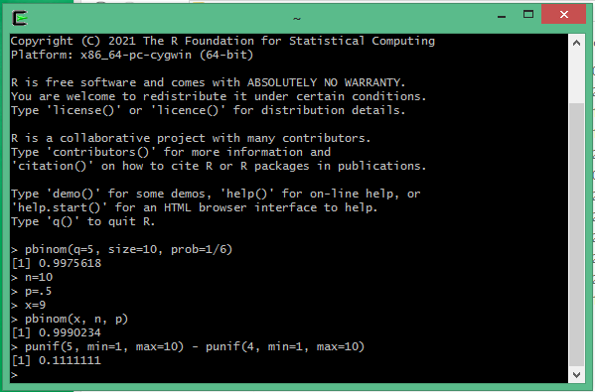

1. b) Here I used the same function but with different input. The input provided here was as variables and not directly through the function’s brackets as before. My input here was 9 instead of 5 as the vector of quantiles, with a size of 10 trials as before saved as the variable n and a probability of .5 which is 50%, a higher probability than the previous function call, giving me a probability answer of 0.9990234 which is also higher.
2. c) The punif function is the cumulative distribution function for continuous uniform distribution in R. Here my overall answer is the subtraction of or difference between two cumulative distributions, both with a lower limit of distribution min of 1 and an upper limit of distribution max of 10 but with different vector of quantile values. The difference between the two cumulative distributions is then 0.1111111.

Total Words (571)